Assignment6.4
TASK 01: Student Performance Evaluation System
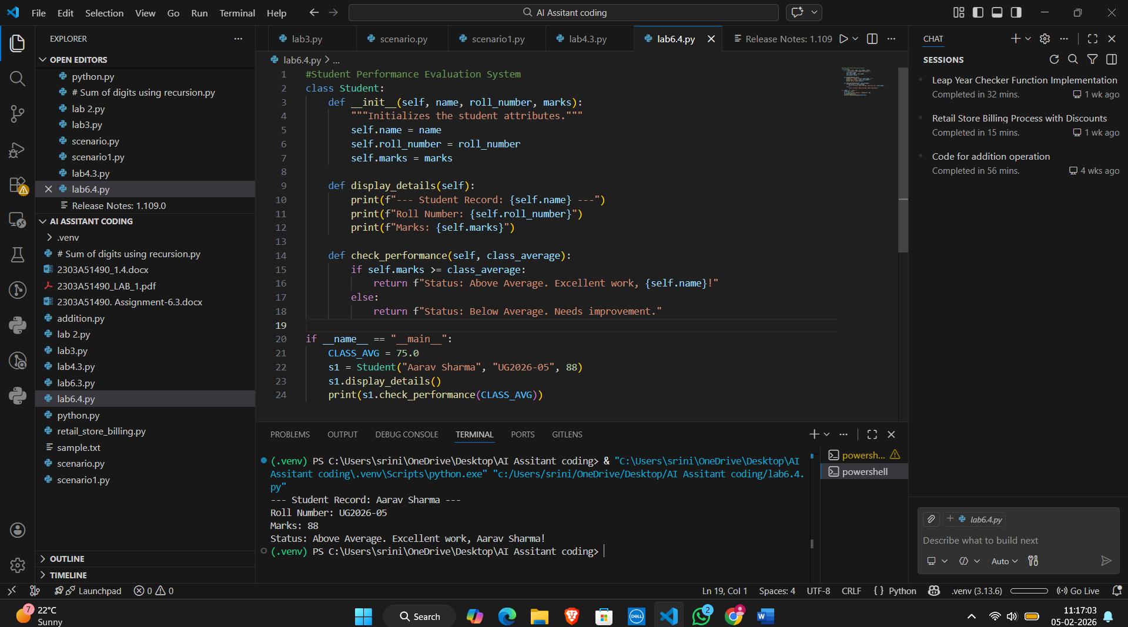
Research Analysis:
The use of "guiding comments" to trigger Copilot highlights a shift in modern software engineering where the developer acts as an Architect (defining the skeleton) and the AI acts as an Implementer (filling in the logic).
TASK 02: Data Processing in a Monitoring System
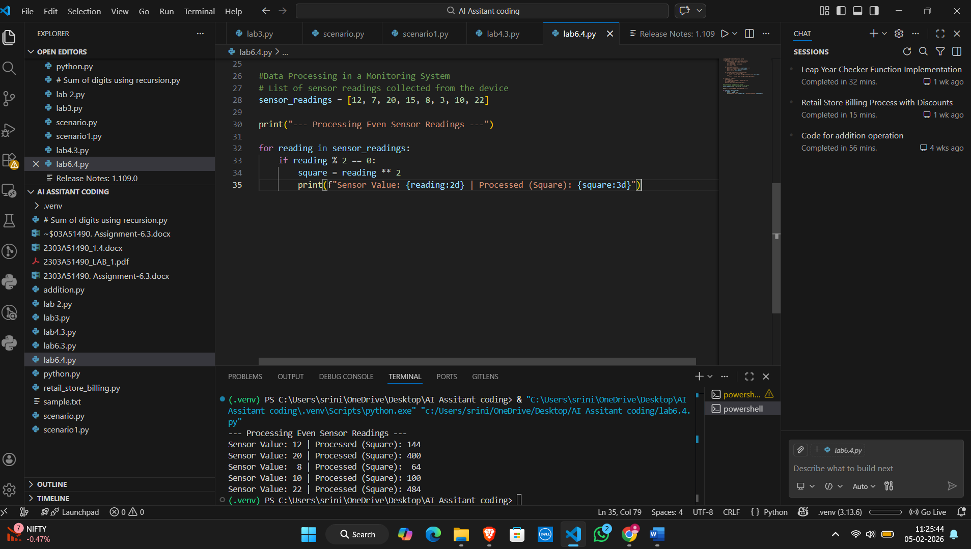
Research Analysis:
Logic and Operator Efficiency
The AI utilizes the Modulus Operator (%) as the primary filter. In computer science, x % 2 == 0 is the standard way to check for parity (evenness). It calculates the remainder after division by 2; if the remainder is zero, the number is even.
TASK 03: Banking Transaction Simulation
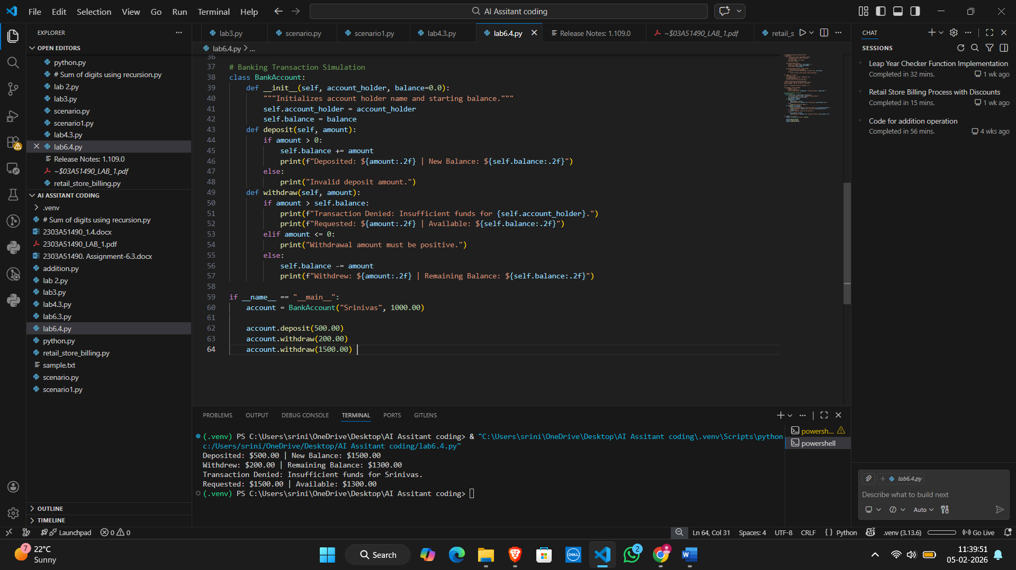
Research Analysis:
• The "self" keyword: By using self.balance, the AI ensures that the withdrawal affects only the specific instance of the account being accessed. This prevents "collision" between different customers' data.
TASK O4: Student Scholarship Eligibility Check
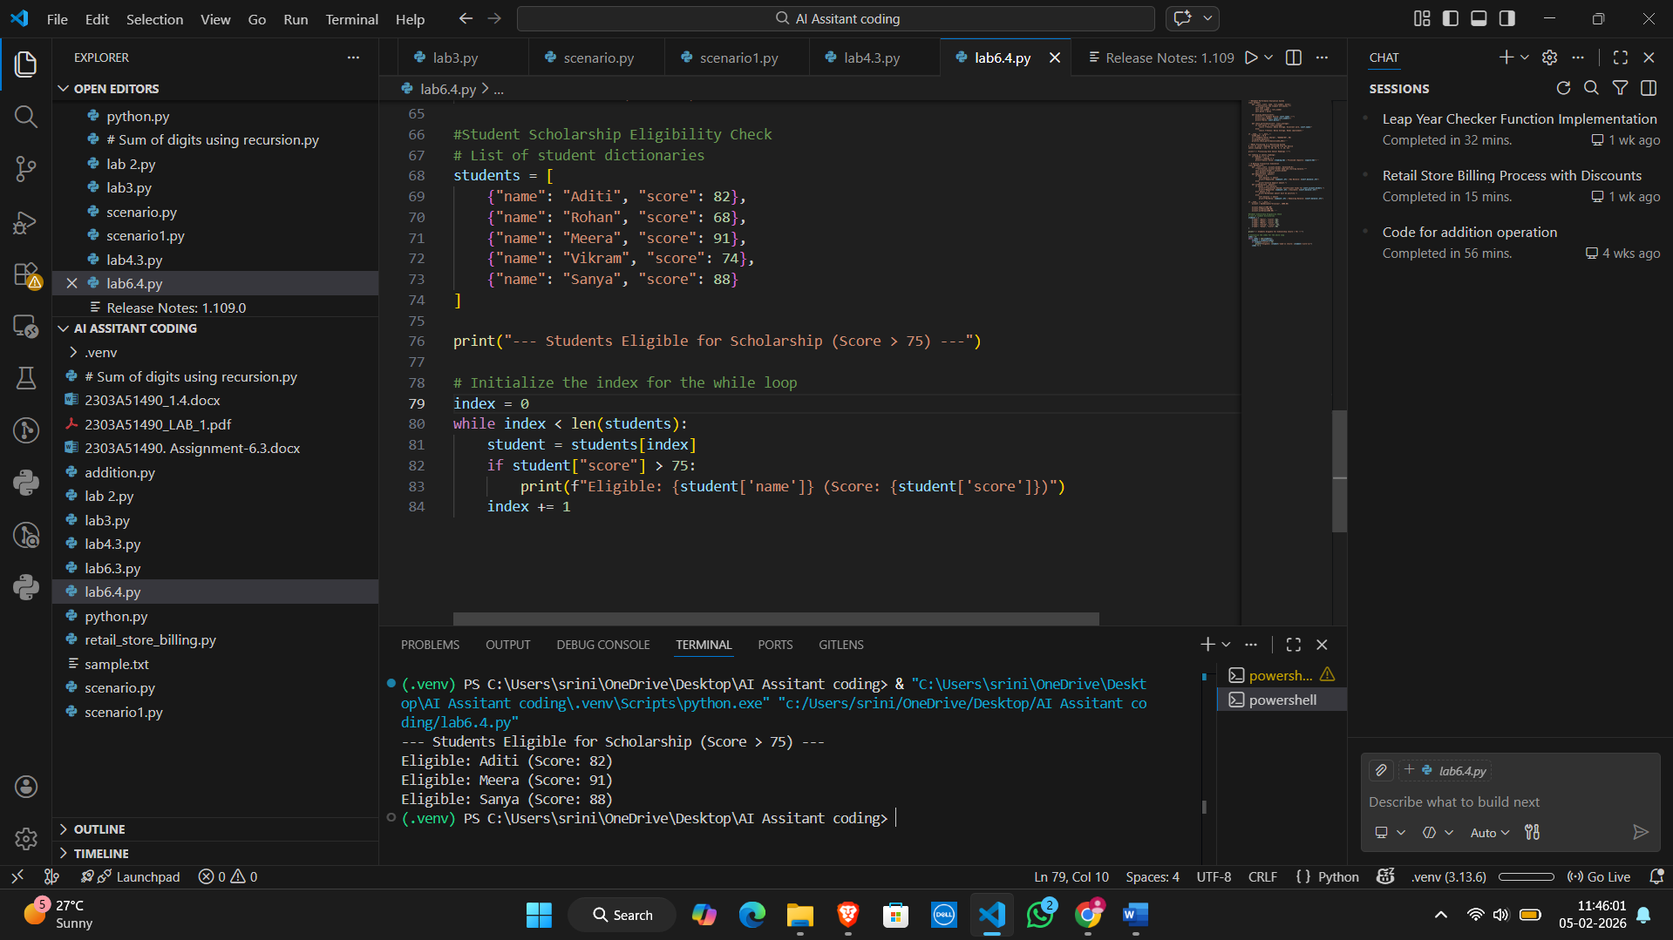
Research Analysis:
A List of Dictionaries is a standard JSON-like format used in web APIs and database records.
TASK 05: Online Shopping Cart Module
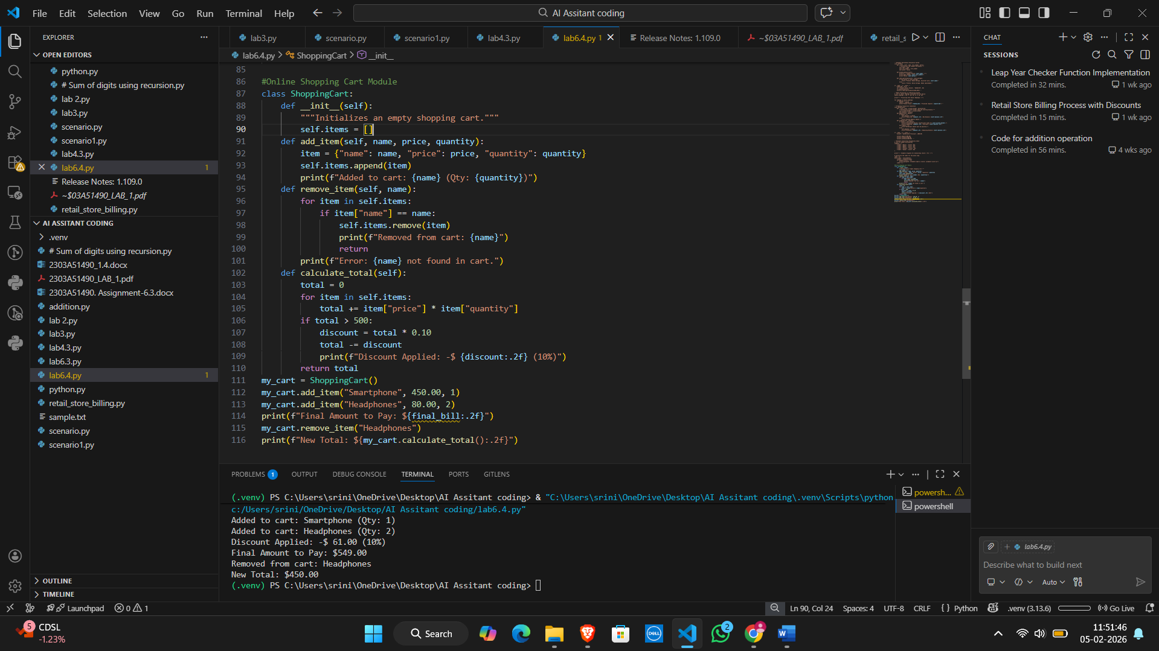
Research Analysis:
The AI uses a List of Dictionaries to represent the cart. This is a common pattern in e-commerce because it allows each item to hold multiple attributes (metadata) like price and quantity while maintaining an ordered sequence.

